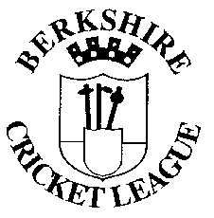 | Berkshire Cricket League  2 Scholars Close  Great Shefford  HUNGERFORD  Berkshire  RG17 7EW
30 July 2026

Dear Sir/Madam,

You are invited to the Berkshire Cricket League Awards Ceremony which is to be held at The Calcot Hotel - Reading on Friday 31st October to sit down at 8.00pm. Please be aware that places are limited and it is on a first come first server basis.

Please detach the slip at the bottom of this letter and return it the League treasurer by Friday 25th October.

It would be preferable to receive 1 cheque from each club made payable to The Berkshire Cricket League at a cost of £27 per ticket.

We would also be grateful if clubs would consider supplying a raffle prize or to give a monetary donation to help support the event, even if your club is not attending.

Many Thanks

Ian Herrington
Berkshire Cricket League Treasurer

Please tick correct box.

________________C. C. will be attending the Berkshire Cricket League Award

Dinner and require ____ tickets. A cheque for £_________ is therefore enclosed

_________________C.C. WIL NOT be able to attend but we enclose a cheque for

£__________ as our donation for the purchase of a raffle prize.

Name: _________________________ Date: ______________________

